WinFrog Waypoint Procedure

- PURPOSE
The purpose of this procedure is to detail the steps involved for all Vessels requiring Adding WayPoint Positions in WINFROG

- SCOPE
This procedure applies to all employees within the Organization.

- RESPONSIBILITY AND AUTHORITY
The Technical Director has the responsibility and authority for ensuring that this procedure is effectively implemented.

- Procedure
  - Verify JOB number is correct per Customer.
  - Select “Quick Rng/Brg” to draw point to desired destination. See Figure 1.

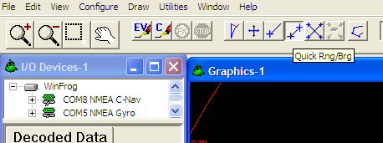
Figure 1

  - Click approximately outside the target first to create the + sign > then continue holding the left key and drag the mouse to the source. Note: This will create the line to the source that will give you the distance > you might have to Click the + again and redraw if the distance is not the desired distance. See Figure 2.

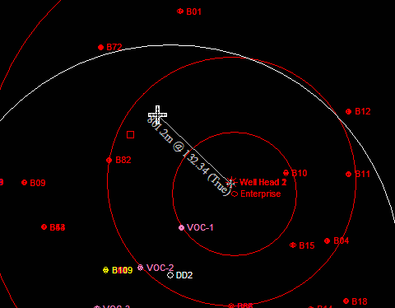
Figure 2

  - Right-Click on the + sign and select “Add Waypoint”. See Figure 3.

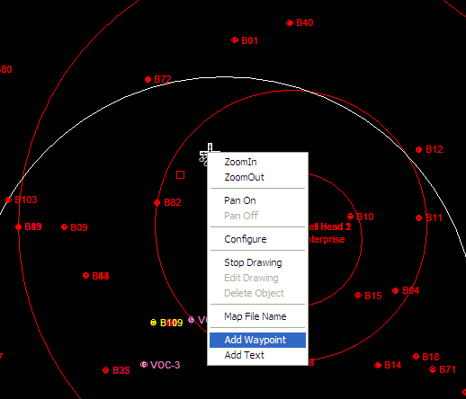
Figure 3

  - Type in the “New Name” for the Waypoint. Verify the Circle Radius is 8.0m or required Radius diameter > Set the Icon to “Bullseye” > Select OK. See Figure 4.

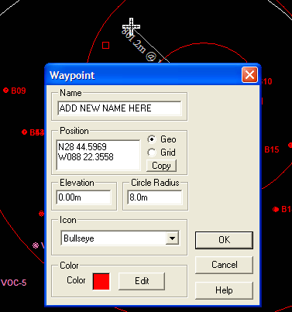
Figure 4

  - Open Notepad and type in the NEW Waypoint Station and Position. Verify it is updated for each site and located in the Secondary monitor (which is in the top-right hand of the monitor). See Example in Figure 5.

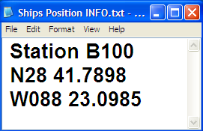
Figure 5

  - Go to File > Edit Working Files > Select Waypoints. See Figure 6.

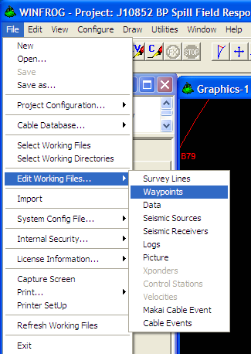
Figure 6

  - Locate & Select (hi-light) the “New” created work file > Select OK. See Figure 7.

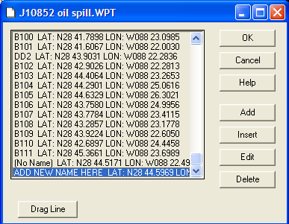
Figure 7
  - Go to the Secondary monitor and Right-Click in Vehicle 1 > Select Waypoint Tracking. See Figure 8.

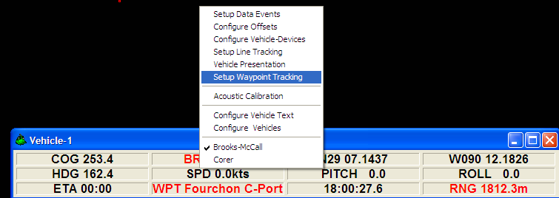Figure 8

  - Go locate and Select the New Waypoint > Select OK. See Figure 9.

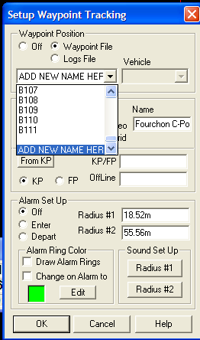
Figure 9

  - Repeat the same process for Vehicle 2. See Figures 10 & 11.

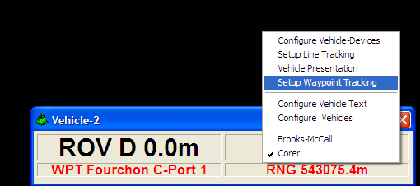
Figure 10

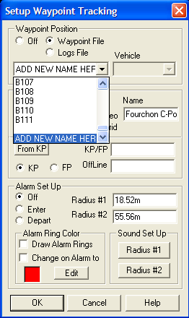
Figure 11

  - Verify Vehicles 1 & 2 have the “New” Waypoint name listed. See Figures 12 & 13.

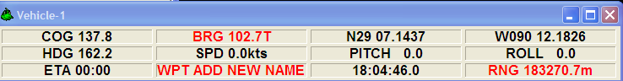Figure 12

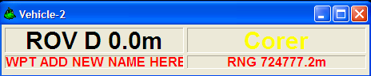
Figure 13

  - Verify the Ship’s Position Notepad is listed in the Top Right-hand corner of the Secondary monitor. See Figure 13.

Figure 14

  - Zoom in on the next station for the Bridge (Secondary monitor) during transit to the next site.
  - ON Position
  - When sample is at bottom or desired depth > Press [F10] > Verify Time and Info is correct in Manual Event Screen > If so, Add into Comments your Initials and Date > Now Select OK. See Figure 15. NOTE: If the Time , Date, and or other data is not correct > Notify the Bridge > close Winfrog > Re-open > then Re-try [F10].

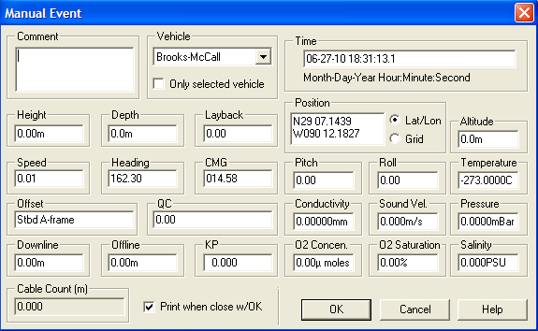
Figure 15

  - A .pdf file will now open > verify it has the correct date, time, info on header > If so > Select file Print and select the printer being used. See Figures 16,17 & 18.

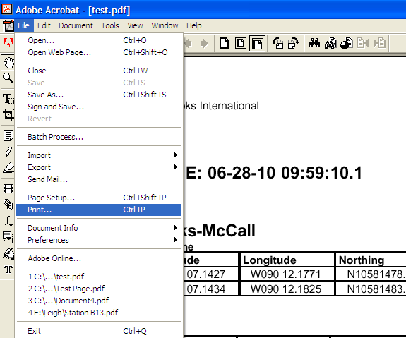
Figure 16

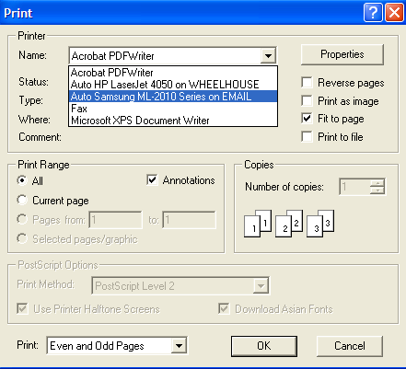
Figure 17

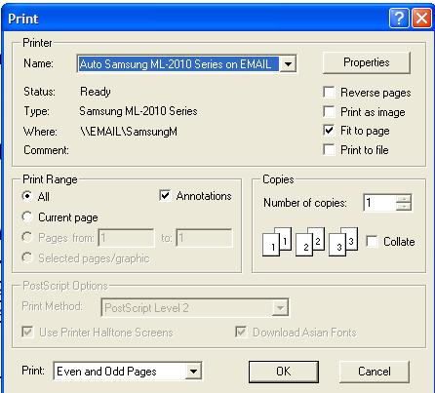
Figure 18

  - Save the .pdf as the “New station Name” in the designated folder per the Job. See Figures 19 & 20 as example.

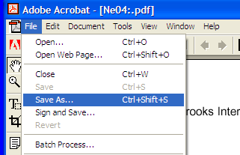
Figure 19

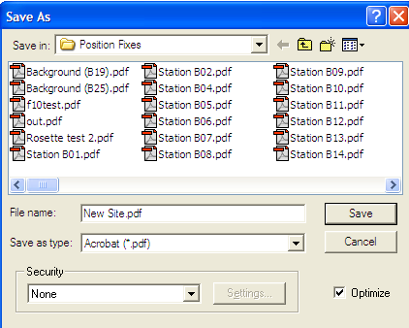
Figure 20

  - Verify the Data prints out > Store the Hard copy for Customer’s record.
  - Go Select the New Waypoint for the Next desired Position > Under Edit Working Files. See Figure 21.

Figure 21

  - Update “BOTH” Vehicles > Under Setup Waypoint Tracking with Next Site.
  - Update Ships Position Notepad and Verify it is located back on the Secondary monitor for Viewing.
  - Zoom in for Next Position > Both Screens.

- RELATED DOCUMENTATION

- Revisions

Section | Description | Date | Approved by:
 | Initial Release | 6-28-10 | G. Patterson

